**CM2003 Concept Report**

**1.** **App Concept:**

Our app provides users with an interactive downloadable map of Kincardine, showing walking and “treasure hunting” routes that the user can follow, along with historical information on the area.

**2.** **Context:**

The main purpose of this map is to provide an interactive means of finding walking routes around Kincardine. Active Aberdeen’s mission is to get people more active and healthy and this app aims to aid in that.This app also makes walking routes more fun by the use of treasure maps.

**3.** **Users:**

The main demographic this app will be popular for will be those already interested in hiking or willing to get into it. There are physical walking maps already in circulation, but nothing digitised and not nearly as convenient as this app.

**4.** **Content:**

This app centres around an interactive map of Kincardine which will provide a user-friendly means of finding walking routes in the area. On top of that users are given interesting historical stories and information provided by the local people of Kincardine about the various locales on this map. Videos and photographs will be uploaded providing more information on the area.

**5.** **Web Service Dependency:**

We will be using the Google Maps API to display interactive maps of the area on the “Maps” page. In the photo/video section, we shall be using the YouTube API to display the videos uploaded by users.

Google Maps: <https://developers.google.com/maps/>

YouTube: <https://developers.google.com/youtube/>

**7.** **User Experience:**

When opening the website, the user is greeted with the homepage. A navigational slideshow will show them the various features on the website and below that an about section, providing details on the app and the company.

Along the top of every page in the site is a row of navigational buttons providing links to the other pages.

After clicking the navigational button marked for the Map Page, the user is redirected to the Map Page. There the user can see an interactive map of Kincardine along with a list of walking routes and “treasure maps”. Upon selecting a route, it is highlighted on the map. Various highlighted points on the map will be shown. When a user clicks one, they are shown some historical information on it, pieced together from local knowledge and other sources. To continue reading this, the user can click on a link which will take them to another page providing them with more historical information on the item.

The user can then click on another route. Then the user can find out information about this route. The user can click on the route that is highlighted and can follow it. They can now use this on their smartphone to follow the path.

The maps can be downloaded as printable files.

Another page on the site is an album page. This shows the user various photos and videos that have been uploaded by other users on the various routes. They are provided a series of albums which organises those pieces of media. The user is also a given an option to upload photos or videos onto the site.

**Wireframes**

Homepage

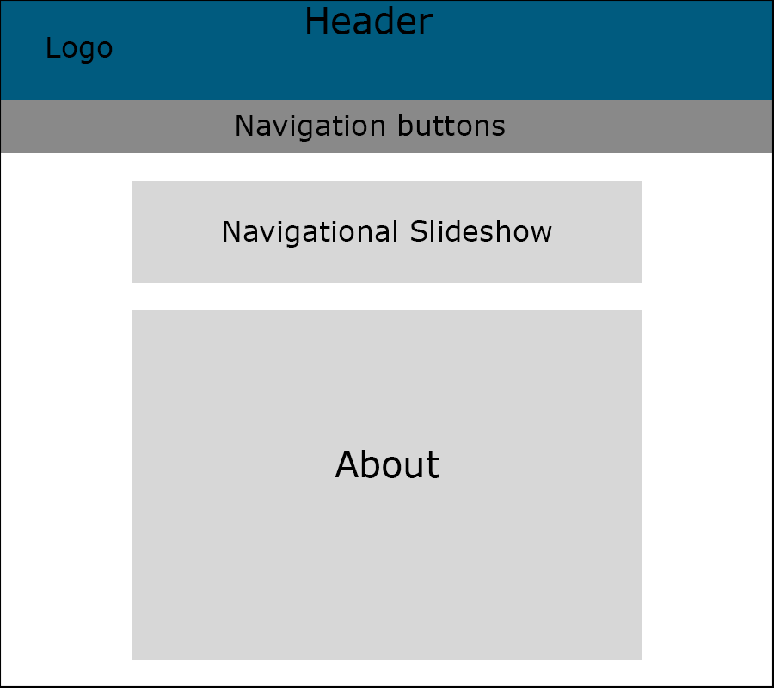

Map Page

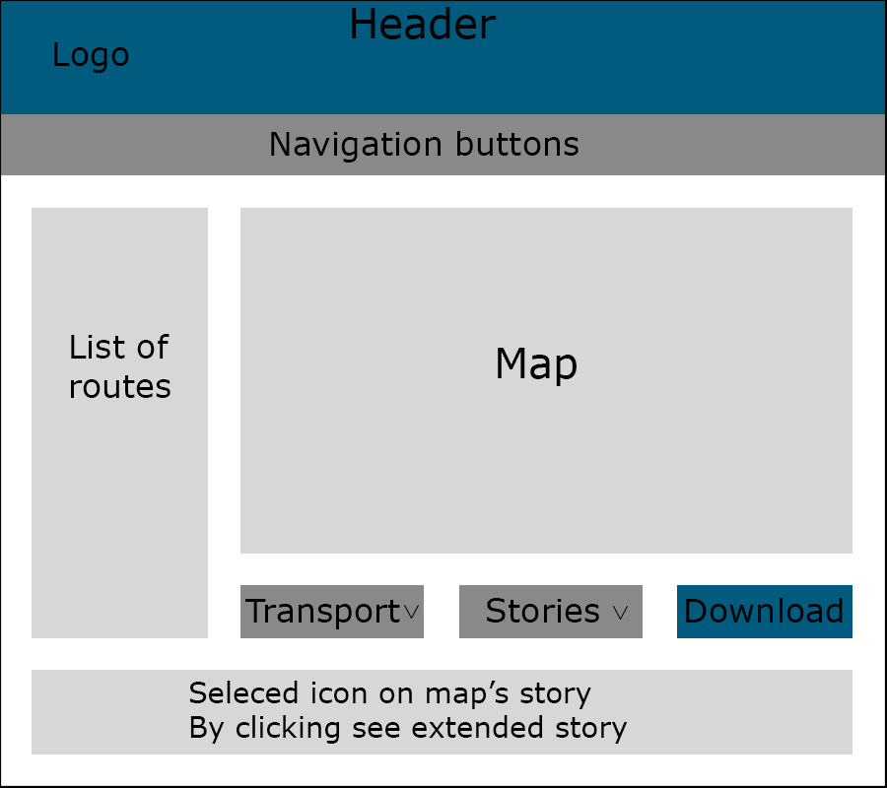

Historical Stories Page

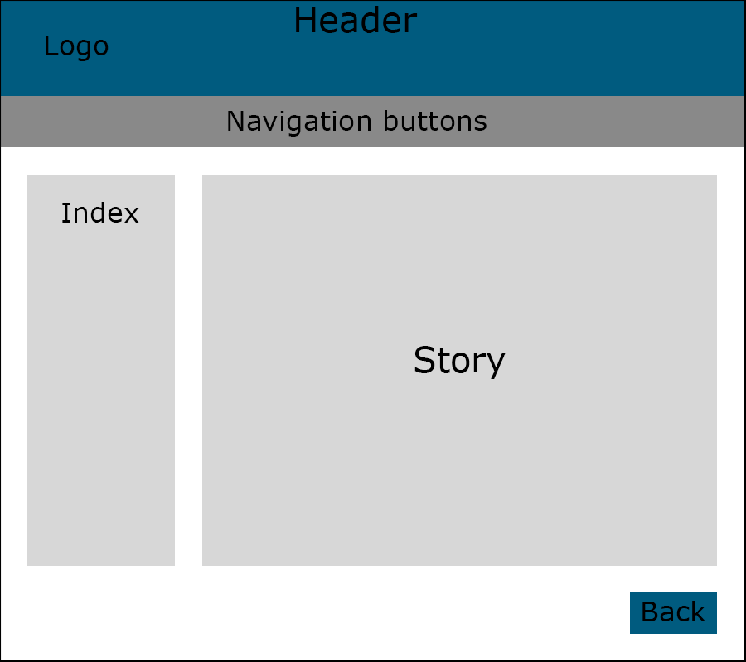

Album Page

